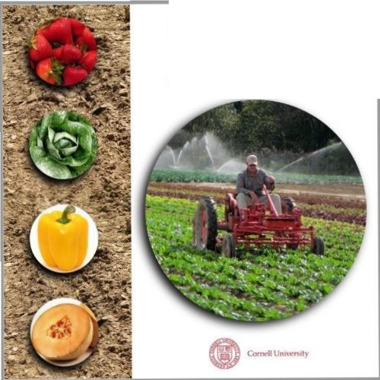Prduce Safety
ALL I ANCE

Grower Training

